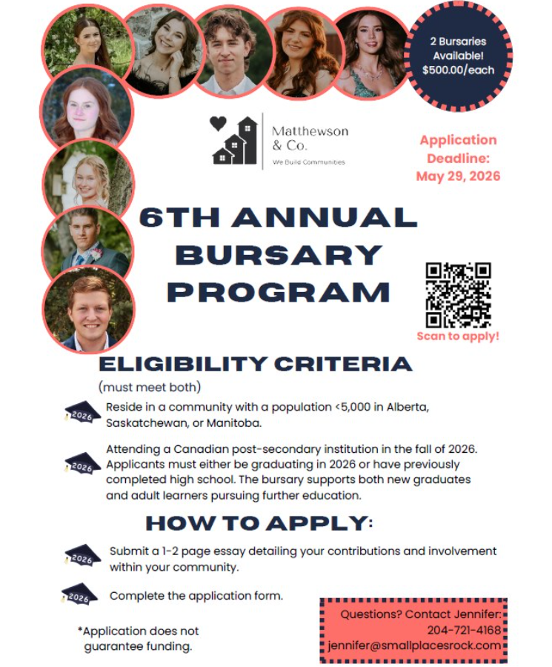

Matthewson & Co. is pleased to share that our annual bursary program is back. This
year, we are offering two $500 bursaries.
Attached isa poster about our 6th Annual Bursary Program, open to students
graduating high school in 2026 as well as individuals who have already completed
high school. The bursary supports both new graduates and adult learners who plan to
attend post-secondary institutions in Fall 2026.
Applications are available at www.smallplacesrock.com, with a deadline of May 29,
2026.
Eligibility:
• Students must live in a community with a population of 5,000 or fewer
• Applicants must be residents of Manitoba, Alberta, or Saskatchewan
To learn more or to apply, please visit: www.smallplacesrock.com/bursaries

