Supply List for Mrs. Adams’ students 2019-2020
Please do not label this list of items below, as we will share. | Please label this list of items below for your child.
A plain colored 1-inch binder with clear front pocket cover *kinders only**  (Grade 1 and 2 will use theirs from last year.) | Indoor non-marking runners (Velcro please), as children get very anxious at being late for gym and do not take the time to tie properly
1 Package of wax crayons | Back pack and lunch kit
1 package of large washable markers | Full ear covering Headphones-no earbuds please, they just don’t fit our little ears
12 small glue sticks | Water bottle
Scissors (Fiskars are good) | Change of clothing (just in case)
3 Hilroy 72 page exercise books/scribblers (at least 2 with half plain half lined pages)
Pencils #2 (sharpened, 24-30ish)
Kleenex box
Small set of watercolors with a brush

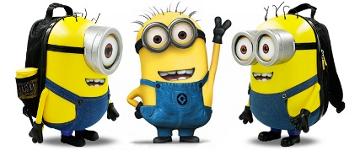
Kindergarten, grade 1 and grade 2 will both start school on Tuesday, September 3^{rd.} Kinder-days for semester 1 will be every Tuesday and Thursday. Mrs. Adams

