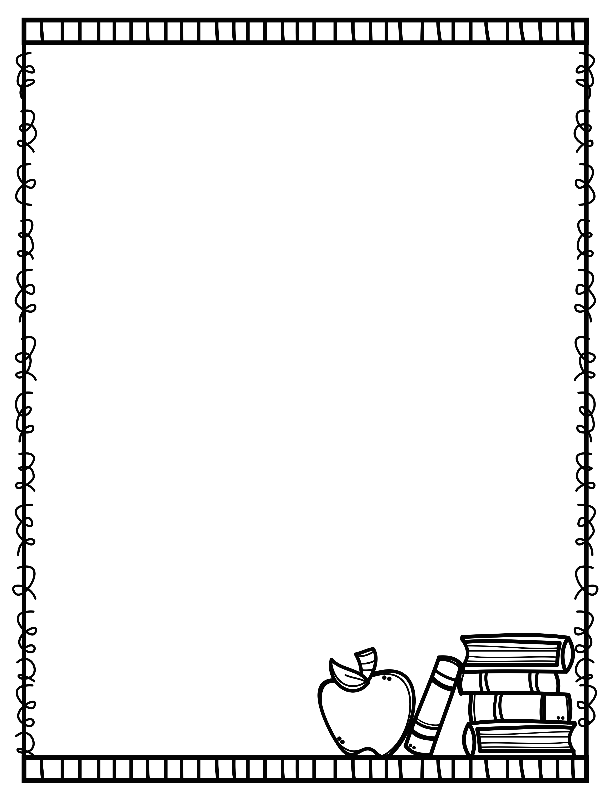
Biggar Central School
Grade 3 - Supply List
2022 - 2023

We would like students to have the following supplies for school next year.

    - 2 Red Pens
    - 4 White Erasers
    - 1 30 centimetre ruler
    - 1 pair of scissors
    - 1 box of wax crayons
    - 1 bottle of white glue
    - 3 pencil case/boxes
    - 8 glue sticks
    - 1 book bag
    - 1 pair of gym shoes - non marking soles
    - 1 old shirt to wear when painting
    - 15 HB pencils (bring as required)
    - 1 pencil sharpener
    - 2 coil notebooks
    - 1 1-inch binder
    - 1 box of pencil crayons
    - 1 box of markers (Mr. Sketch is best)
    - 10 Hilroy Exercise books (multi coloured package)
      - please make sure the notebook has lines on the whole page
    - 1 pair of ear buds/headphone
    - 1 pkg. plastic cutlery

If you are unable to find name brand items
listed, please purchase a suitable
and comparable substitute.

