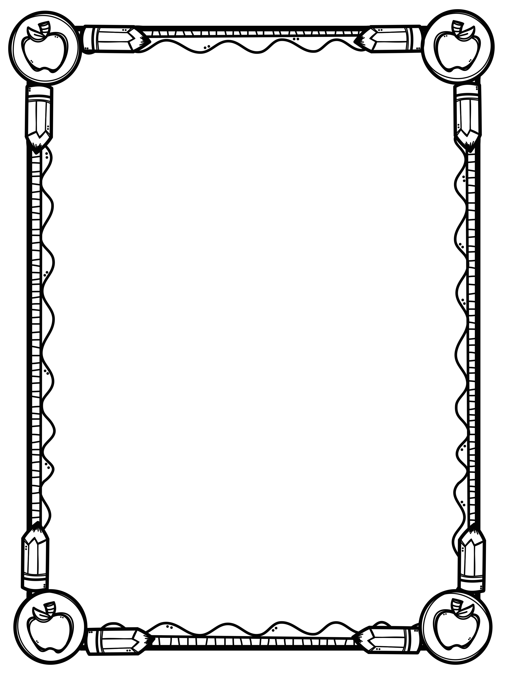
Biggar Central School
Grade 4 - Supply List
2021-2022

We would like students to have the following supplies for school next year.

    - 1 Package of loose-leaf
    - 4 Highlighters (different colors if possible)
    - 4 Red Pens
    - 2 Erasable blue pens
    - 4 White Erasers
    - 1 30 centimetre ruler
    - 1 pair of scissors
    - 1 box of wax crayons
    - 1 box of pencil crayons
    - 1 box of markers
    - 1 bottle of white glue
    - 2 pencil case/boxes
    - 5 glue sticks
    - 20 HB pencils (students may also use mechanical pencils, if they wish)
    - 1 book bag
    - 1 pair of gym shoes - non marking soles
    - 1 old shirt to wear when painting
    - 3 boxes of kleenex
    - 1 pencil sharpener
    - 5 32-Page Hilroy Exercise books (lined)
    - Standard Binders (no zipper binders):
      - 1 – 1 inch for social/science
      - 1 – 1.5 inch for math
      - 1 – 2 inch for ELA
    - 3 Sets of Binder dividers
    - 1 set of standard earphones/earbuds
    - 1 water bottle

If you are unable to find name brand items listed, please purchase a suitable and
comparable substitute.

We would greatly appreciate it if you would label your child’s supplies.

Thank You!

