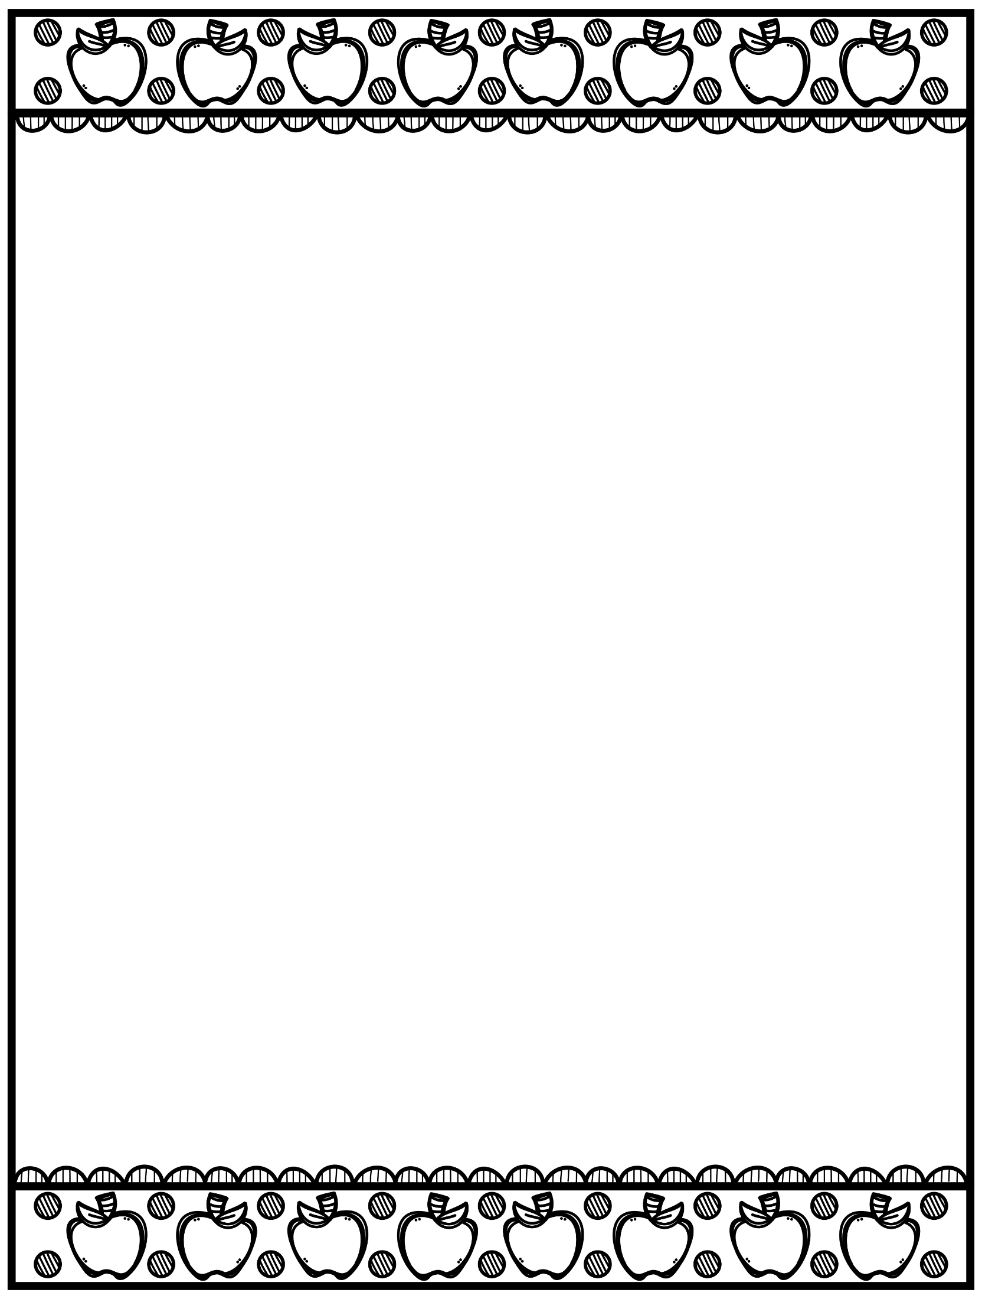

**BCS 2000 Kindergarten Class Supply List   
2022 - 2023**

**Required Supplies per student:**

* 1 backpack
* 2 boxes of Kleenex
* 3 whiteboard markers
* 1 pair of primary scissors
* 3 primary (LARGE size) pencils per student
* 1 eraser
* handheld pencil sharpener
* 1 box of crayons
* 4 glue sticks
* 1 package of **Crayola** markers
* 2 interlined notebooks
  + each page should be half-lined and half-clear for drawing a picture
* 1 water bottle
* 1 change of clothes
* 1 pair of earbuds/headphones