Biggar Central School
Grade 2 Supply List | 2022-2023
We would like students to have the following supplies for school next year. These supplies were specifically chosen based on the needs of the Grade 2 curriculum and the size constraints of the desks and classroom furniture. Please look for these specific supplies when possible. Thank you!
- 4 White Erasers
- 1 - 30-centimetre ruler
- 1 pair children’s Fiskars scissors
- 1 box wax crayons (24 count)
- 2 bottles white glue
- 2 pencil boxes (smaller size)
- 8 large glue sticks
- 1 backpack (please no rolling backpacks as they are too large to fit into shared lockers)
- 1 pair gym shoes – non marking soles
- 1 paint shirt
- 40 HB or #2 pencils - sharpened
  - I prefer Ticonderoga brand, as the lead in cheaper brands break inside the pencils and cause sharpening issues!
  - Not decorative, please!
- 1 box pencil crayons
- 1 box markers
Please flip over.
- 6 Duo-Tangs (1 red, 1 yellow, 1 dark blue, 1 orange, 1 green, 1 black, 1 grey)
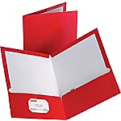
- 2 – 2 pocket folders (1 red), (1 green), (not plastic, please!)

- 2 Hilroy Interlined Exercise books (half page of lines - Walmart, Staples)
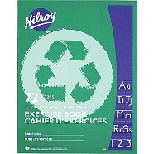
- 2 Hilroy Interlined Exercise books (whole page has lines - Walmart, Staples)
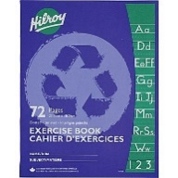
- 1 Hilroy 8mm ruled notebooks (whole page has lines – Walmart, Staples)
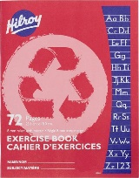
- 1”Binder
- 1 pair earphones (labelled with name)
*Please have all items labeled with child’s name.*
*Thank you!*

