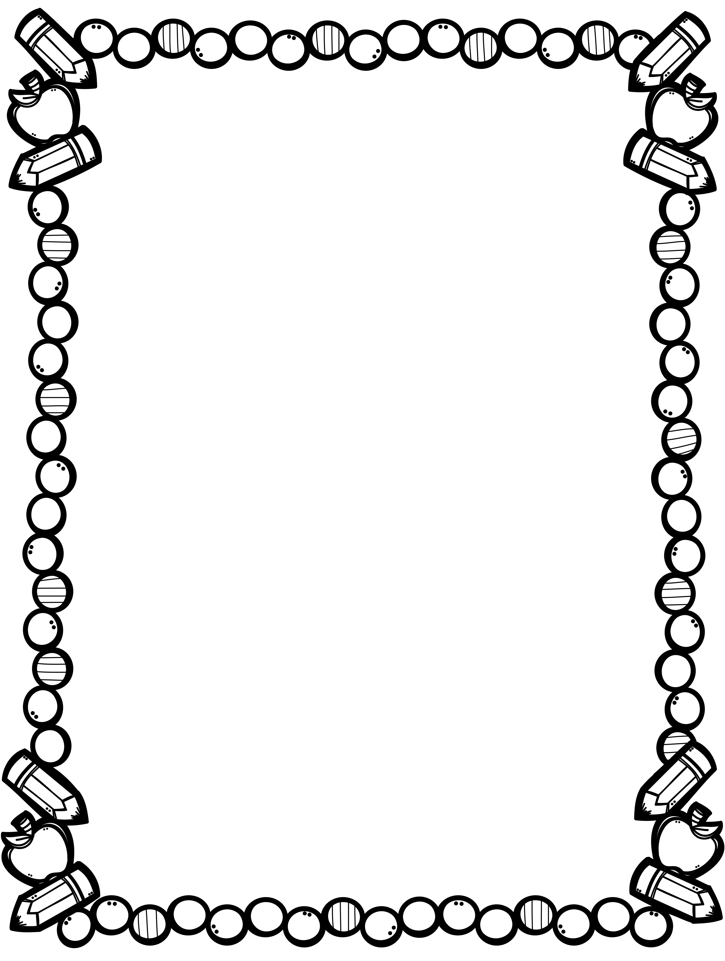

**Biggar Central School 2000**

**Grade 1 Supply List**

**2022 – 2023**

We would like students to have the following supplies for school next year:

* + - 6 White Gum Erasers
    - 1 30 centimetre ruler (bendable is best)
    - 1 pair of scissors (Fiskars)
    - 2 boxes of wax crayons (16 – 24 or more)
    - 1 bottle of white glue
    - 2 Large pencil cases
    - 8 glue sticks (large or 16 small)
    - 1 book bag
    - 1 pair of gym shoes - non marking soles
    - 1 old shirt to wear when painting
    - 30 HB pencils
    - 5 Hilroy ½ and ½ Interlined Exercise books
    - 9 duotangs
    - 1 pencil sharpener
    - 1 package of markers, fat tip (Mr. Sketch)
    - 1 package of markers, skinny tip
    - 1 package of pencil crayons
    - 5 sturdy plastic pocket folders with pockets for holding notes/agendas
    - 1 pair of headphones to be used with an iPad or laptop

Please pack one pencil case with 1 pencil, 1 eraser, 1 pair of scissors, and 1 glue stick.

***Please label all your child’s supplies! If you label all your supplies, including your child’s crayons, markers, pencil crayons and pencils, I can make sure they have a complete set for the school year! Thank you! ☺***

If you are unable to find name brand items listed, please purchase a suitable   
and comparable substitute.